Using Cambridge School Support Hub materials to enhance the teaching of Cambridge Lower Secondary Science

Finding up-to-date, well researched teaching and learning material is a time consuming and challenging job for all teachers. As part of the Cambridge programme fee, you will find a huge variety of materials available that you can use to plan, teach and assess your learners. These documents are on the School Support Hub for Lower Secondary Science:
- Checkpoint end of series examiner report
- Progression grids
- Sample Progression and Checkpoint tests
- Schemes of work
- Teacher guides
- Past papers – Progression Tests and Checkpoint.

To illustrate this, we will use a Stage 9 learning objective from the Cambridge Lower Secondary Science Curriculum Framework and show you the support that is available to teach it.

9TWSc.03 Decide when to increase the range of observations and measurements, and increase the extent of repetition, to give sufficiently reliable data.

We have chosen this example because it is often difficult for learners.

You can use the end of series examiner reports to find out which learning objectives assessed in Cambridge Lower Secondary Checkpoint were difficult for many learners. But don’t worry if your learners find something else difficult. There are support materials for every learning objective on the Cambridge Lower Secondary support site.

End of series examiner report
The Cambridge Lower Secondary Checkpoint End of Series Report from May 2019 (pages 106 and 109) states that candidates did not realise the importance of sample size in scientific enquiry.
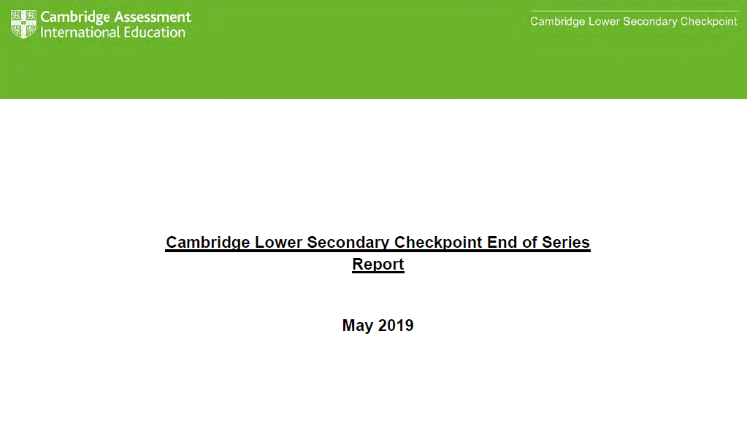
In terms of Science Enquiry questions, many learners confused the terms accuracy and reliability in their answers.

Question 8

This question about the population of birds assessed aspects of Science Enquiry.
(a) Learners could often not give an adequate explanation for why a large sample size was important. Learners mentioned factors such as a fair test or accuracy but rarely mentioned reliability in their answer.

Figure 1: Extracts from the Cambridge Lower Secondary Checkpoint End of Series Report,
May 2019 (pages 106 and 109)

Progression grids
Before you start teaching your Stage 9 learners about reliability and repetition, you can see learners’ prior learning in our progression grid (the progression grid for science can be found on the Cambridge Lower Secondary support site below the Curriculum Framework).

From the progression grid extract below, you can see that in Stage 8 learners have already begun to evaluate repeated observations and measurements to decide if they are reliable. This should have developed some awareness in learners that ‘reliability’ is a description of how close repeated measurements are to each other. In Stage 9 they apply this understanding to their own investigations, being able to make informed decisions about how many repeated observations and measurements are required for each specific investigation.

Stage 8 | Stage 9
8TWSc.03 Evaluate whether measurements and observations have been repeated sufficiently to be reliable. | 9TWSc.03 Decide when to increase the range of observations and measurements, and increase the extent of repetition, to give sufficiently reliable data.
Figure 2: Extract of learning objectives 8TWSc.03 and 9TWSc.03 from the Cambridge Lower Secondary Science progression grid

There are progression grids for each Cambridge Lower Secondary subject. These provide you with reassurance that concepts have been systematically developed and that you are progressing your learners in sustainable, well researched steps. They also make it easy to identify what your learners should know, understand and be able to do from different strands in science and in different subjects.

Progression Tests – Stage 8 sample paper
You can also check your learners’ prior learning by using questions from the previous stage Progression Tests. In this case, Question 11b from a Stage 8 Progression Test asks learners to suggest ways that Aiko can improve her investigation. 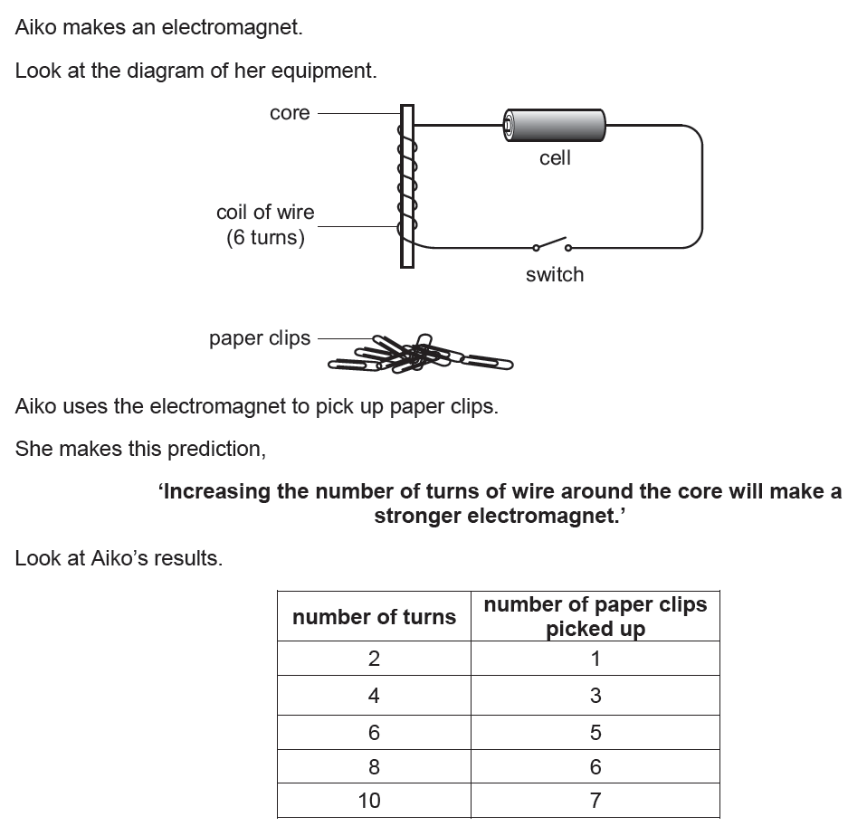


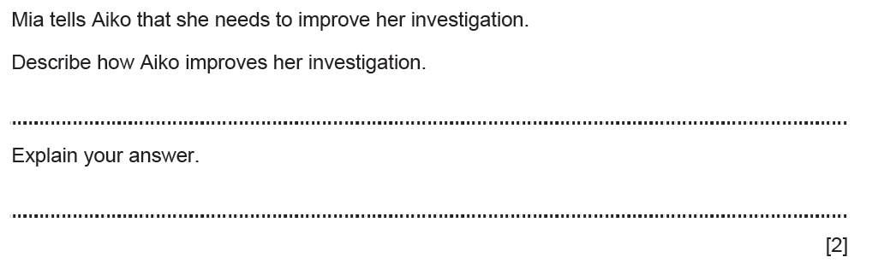
Figure 3: Question 11b from Stage 8 Progression Test paper 2 – 2022

You could use this as a starter activity for a Stage 9 lesson, asking learners to think of several different improvements with an explanation for each.

The mark scheme for this paper gives three main options:

- Description: repeat the experiment (for each number of turns)
Explanation: as this will improve the reliability of the experiment / so results can be checked / so averages can be taken

- Description: do the experiment with different number of turns, e.g. 1, 3, 5, 7 and/or 9 turns
Explanation: makes it easier to see any patterns / as this will provide more data

- Description: use smaller paper clips
Explanation: (idea that) more paper clips are picked up / improves accuracy

You can use your learners’ answers to identify if they consider repeating the experiment and importantly if they link this to increasing the reliability (or mistakenly think it improves accuracy). This can inform you whether you can move on to new learning or if you need to spend time reviewing and reinforcing previous learning.

Schemes of work
Our schemes of work provide ideas on possible activities to teach each learning objective. For the content learning objectives in Biology, Chemistry, Physics, and Earth and Space, there are also suggestions of key vocabulary, possible models and representations that can be used, and misconceptions that learners may have. It is often difficult to update yourself on latest research findings and teaching activities, so this research has been consolidated for you in our schemes of work.

We would start by looking at the Stage 9 Scheme of Work. If you use the learning objective code (9TWSc.03) you will be able to find the information related to this learning objective. As this is a Thinking and Working Scientifically learning objective it needs to be combined with a content learning objective to provide context.

In the example below it is combined with learning objective 9Pf.02 on heat and temperature. The activities specifically related to 9TWSc.03 have marked with green text. This approach to teaching 9TWSc.03 is an example that could be applied to many other practical activities.

Learning objective | Thinking and Working Scientifically opportunities | Suggested teaching activities and resources
9Pf.02 Describe the difference between heat and temperature. | 9TWSc.03 Decide when to increase the range of observations and measurements, and increase the extent of repetition, to give sufficiently reliable data.  9TWSc.04 Take appropriately accurate and precise measurements, explaining why accuracy and precision are important.  9TWSp.04 Plan a range of investigations of different types to obtain appropriate evidence when testing hypotheses.  9TWSa.02 Describe trends and patterns in results, identifying any anomalous results and suggesting why results are anomalous.  9TWSa.05 Present and interpret results, and predict results between the data points collected | Heat and temperature  Explore learners’ understanding of temperature by providing a range of images (e.g. sun, hot bath, hot cup of tea, swimming pool, sparkler). Learners, working in pairs (or groups of three), rank the images in order of hottest to coldest based upon their experiences. After five minutes, discuss rankings with another group.  To explore learners understanding of the difference between heat and temperature, ask learners to describe (or name) something that has:  - a high temperature and a lot of heat (e.g. a furnace, the Sun, magma/lava)  - a low temperature and a lot of heat (e.g. a heated swimming pool, a warm ocean current)  - a low temperature and not have much heat (e.g. a cup of warm tea)  - a high temperature and not much heat (e.g. a spark from a fire).  Provide groups of learners with stopwatches, thermometers and three 250 ml beakers filled with different volumes (50 ml, 100 ml, 150 ml) of water at the same temperature; the volume of water should be measured using measuring cylinders.  Ask learners to design their own investigation using the equipment provided to identify the relationship between heat and temperature. Learners share their plans and discuss which investigation type was chosen and why. Discuss with learners the importance of being accurate and precise and how they can be accurate and precise with their measurements in their investigations.  A possible investigation to run if learners have varied approaches or have flaws in their investigations: Learners suspend a thermometer in each beaker using a clamp stand, boss and clamp; the thermometer should not be touching the bottom of the beaker. They use stopwatches (or stop clocks) to time how long each beaker takes to reach 60°C, heating the beaker with a 4-5 cm Bunsen burner flame.  If the equipment required is limited or not available, the following data can be provided to learners in place of carrying out the investigation themselves:  Group A  Volume of water (ml) Time to reach 60^{O}C (s)  50 25  100 40  150 165  Group B  Volume of water (ml) Time to reach 60^{O}C (s)  50 35  100 110  150 125  Using the experimental data (their own or provided) ask learners:  What is the relationship between the volume of water in the beaker and the length of time needed to heat the water to 60^{O}C?  Why does a larger amount of water take longer to heat up than a smaller volume?  What shape of graph would we expect if ‘time needed to heat the water to 60^{O}C’ was plotted against ‘volume of water in the beaker’?  If learners obtained their own data, discuss with learners if any of their data was anomalous. Discuss with learners why they may have anomalous results.  Discuss with learners why a larger volume of water takes longer to reach 60^{O}C. Explain that this is because more heat energy is needed to heat the larger volume of water to 60^{O}C.  Ask learners to plot a graph of their three results. Discuss the type of graph selected and what their graphs show. It is likely that few groups will obtain a straight-line graph as this investigation tends to yield variable results. Describe some of the variables that are difficult to control (e.g. draughts, heat losses from the beakers, height of the flame, position of the flame under the beaker, the position of the thermometer in the beaker). Learners, working in groups, list a series of strategies that would yield more reliable results.  Strategies could include:  - Using a wider range of water volumes in a larger beaker (e.g. 50 ml to 500 ml in a 600 ml beaker, increasing by 50 ml each time).  - Using more water volumes between 0 ml and 150 ml (e.g. 25 ml to 150 ml, increasing by 25 ml each time).  - Repeating each reading at least three times, discarding and repeating anomalous results. Take an average of the results within range.  - Improving the equipment by using an insulated beaker that reduces heat losses.  - Improving the procedure by keeping a constant flow of gas to the Bunsen burner and stirring the water.  Ask the learner groups to explain how their proposed improvements would increase the reliability of the data. If possible, learners carry out a refined investigation to generate more data and create a graph that is more meaningful.  Show learners an ideal graph and model using the graph to predict what other results/data points could be. Provide the graph to learners and ask them to identify likely experimental data they would expect from the graph. Discuss this is one way scientists check the validity of data; by interpreting a small set of data, making predictions and then seeing if their predictions are correct.  Recap with learners that:  - Heat is a measure of how much energy is transferred to a substance (which results in an increase in kinetic energy of the particles) and is measured in Joules (J).  - Temperature is a measure of how hot something is (the average kinetic energy of the particles) and is measured in degrees Celsius (°C).  Resources: Images of objects at different temperatures, Bunsen burners, tripods, 250 ml beakers, measuring cylinders, thermometers (do not use mercury thermometers), stopwatches, clamp stands, bosses, clamps
Figure 4: Extract from Stage 9 Scheme of Work – activities for learning objective 9TWSc.03

Teacher guide
The Cambridge Lower Secondary Science Teacher Guide has useful advice for assessing and supporting learners. For example, in Section 5.2 Developing success criteria, it suggests various ways of using success criteria while supporting you on how to develop them.

You could use the principles in the teacher guide to create success criteria for 9TWSc.03.

9TWSc.03 Decide when to increase the range of observations and measurements, and increase the extent of repetition, to give sufficiently reliable data.

Example success criteria:
- I can identify the range of observations or measurements in a scientific investigation.
- I can identify the number of repeats in a scientific investigation.
- I can explain the meaning of the term ‘reliable’.
- I can explain the difference between results being ‘reliable’ and ‘accurate’.
- I can explain how to obtain reliable data in my investigations.
- I can decide when I need to change the plan for my experiment to get sufficiently reliable data.

These success criteria should be shared at the beginning of your lesson so learners can monitor if they have been successful in their learning. You and your learners can regularly refer to them as you teach and to record their progress.

Progression Tests or Checkpoint – Stage 9 past papers
Finally, as part of your end of topic assessment you can use questions from past Stage 9 Progression Tests or from past Checkpoint tests to ensure that your learners have consolidated their learning. These questions have been developed by Cambridge using robust assessment principles. They ensure that learners are assessed only on what is in the curriculum and that the information you get from their responses is meaningful and a true picture of their learning.

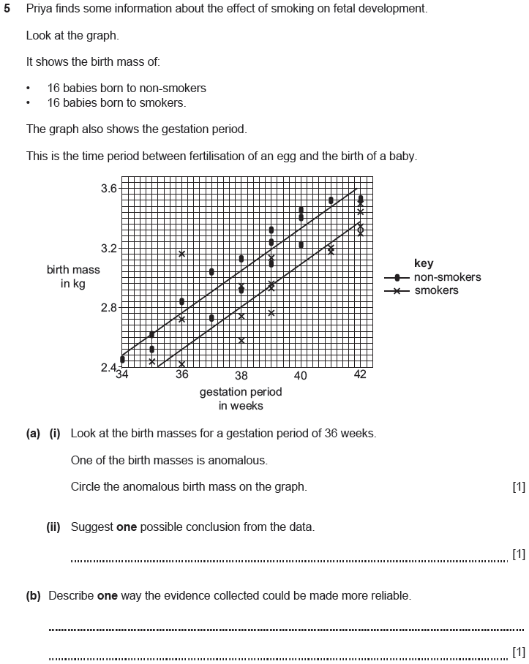
Figure 5: Question from Stage 9 Progression Test – 2022
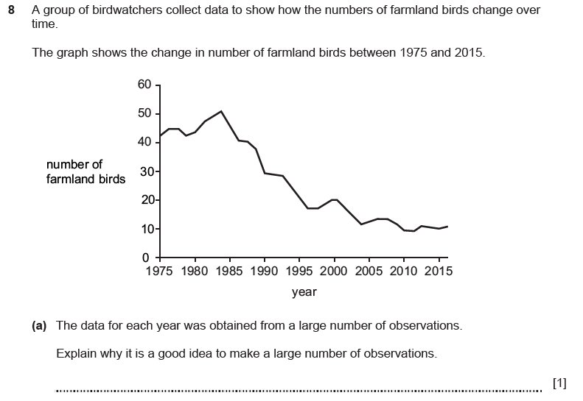
Figure 6: Question from Cambridge Lower Secondary Checkpoint paper 2, May 2019

Teaching is a busy profession and new ideas for innovative teaching and new research about how children learn is consistently being shared. It is difficult for you to keep well-informed of what researchers have found about misconceptions learners can develop and what strategies can be used to minimise these. Regularly using the various resources available on our Cambridge Lower Secondary support site, you can be reassured that you are using quality teaching resources which have been developed from extensive research.

By
Aman Sidhu and Judith Roberts – Curriculum Programmes Managers

This document was previously published as a blog in November 2022

We are committed to making our documents accessible in accordance with the WCAG 2.1 Standard. We are always looking to improve the accessibility of our documents. If you find any problems or think we are not meeting accessibility requirements, contact us at info@cambridgeinternational.org with the subject heading: Digital accessibility. If you need this document in a different format, send us an email with your name and requirements and we will respond within 15 working days.

